HOSPITAL PATIENT FLOW OPTIMIZATION USING REAL-TIME VITAL MONITORING AND DYNAMIC QUEUE SCHEDULING

Department of Electronics and Communication Engineering, SRM Institute of Science and Technology, Kattankulathur, Chennai, Tamil Nadu 603203, India

- INTRODUCTION
In today's health care facilities, patient flow is essential to maintain the efficient delivery of health care services and has a direct impact on the quality of service provided, patient satisfaction, and clinical outcomes. In the era of growing patients in hospitals, particularly in urban areas, traditional hospital management system faces many challenges for managing patient inflow. Even if the waiting time is reduced in hospitals, the registration and triage of patients, and allocating the consultation, are still largely manual processes, causing overcrowding, and inefficient use of medical resources. Managing these hurdles are especially crucial in outpatient departments and emergency units, where it is important that critical patients be identified and prioritized in time, otherwise the outcomes of treatment can be affected. One of the drawbacks of the conventional systems is the absence of intelligent scheduling and real time decision making.
A simple First Come First Serve (FCFS) strategy is typically used to treat patients, ignoring the actual level of severity of their condition. Also, lack of integration between patient monitoring, queue management and doctor allocation creates unsynchronized workflows and unbalanced workloads among healthcare professionals. Several systematic investigations efforts have been made on predictive and analytical measures, which are the things they will have to go through. Previous studies have explored different approaches on improving patient and time management. A machine learning-based approach has been applied for estimating waiting times of medical procedures based on historical data of the hospital [1]. In the field of emergency department patient flow, queueing theory has also been widely used to analyse patient flow in the ED. The scheduling policies like (FCFS) and priority-based have been shown in the studies that proper scheduling policies can drastically decrease the waiting time and gain the overall efficiency of the operation [2].
Additional improvements are investigated using working optimization via simulations. Departments have been able to highlight patient journeys to various hospital areas and areas of inefficiency by modelling patient movement across different hospital researchers. Better bed allocation and healthcare delivery coordination between departments were observed to decrease treatment delay and improve healthcare delivery [3]. Intelligent systems have also been developed that are hybrid to enhance queue management. These advanced approaches have combined artificial intelligence and optimization algorithms to improve scheduling decisions and service efficiency. This pairing can improve resource utilization as well as prediction accuracy and therefore decrease waiting time [4], [5]. Furthermore, the automated service queue management system based on (FCFS) scheduling is extended to the health checkup service in hospitals, although basic approaches may not adequately address the prioritization of critical patients [6]. Despite these developments, the software-based models, simulation methods, or computationally demanding algorithms that are available today are largely targeted towards the software aspects of the solutions. The need is still there of developing a low cost, real time, hardware integrated system, which integrates patient registration, vital parameter monitoring, intelligent prioritization and dynamic scheduling in one system.
To close this gap, the proposed Hospital Patient Flow Optimizer is presented as an embedded system-based solution which incorporates sensor-based measurement of vital parameters, automatic generation of patient tokens, and intelligent queue management. The system uses scheduling algorithms like FCFS, Priority Scheduling, and Round Robin to ensure efficient patient flow. This will reduce overcrowding, minimise waiting time and improve overall hospital efficiency, by prioritising critical patients and the efficient distribution of work load to doctors. It has a low cost and is real-time, making it an ideal solution for deployment in resource-constrained healthcare settings. This paper is organized as follows: All the scheduling policies used, mathematical formulations employed for queue management and the design and working of the proposed prototype is described in the Materials and Methods section. The results achieved and the analysis thereof is discussed in the Results and Discussion section. Finally, the paper is concluded in the Conclusion.

2. MATERIALS AND METHODS
2.1 Queue Scheduling Strategy and Mathematical Formulation
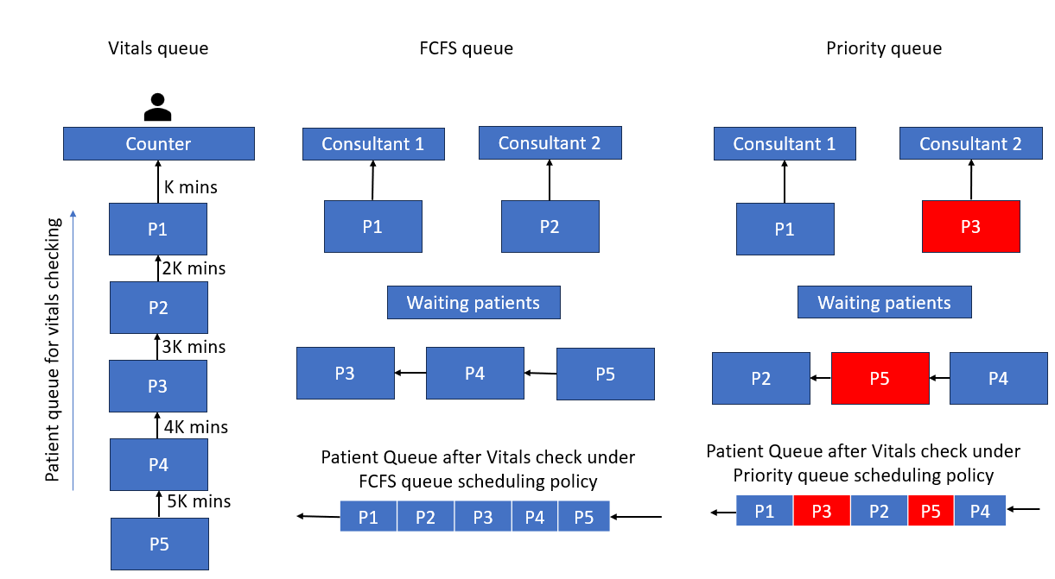
We propose a system where queue scheduling strategies are deployed at different stages of patient flow. By doing so, patients are handled efficiently and fairly. Fixed time service is used as the scheduling principle at the critical measurement stage following the Round Robin scheduling technique. First Come First Serve (FCFS) and Priority Scheduling are used at the consultation stage depending on the patient's medical condition. Mathematical calculations are presented to find the estimated waiting time of each stage and the average waiting time for patients. The provided queue scheduling strategies allow the system to adaptively process the patients , queue by allowing critical patients to jump the line and avoid overcrowding and unnecessary waiting.

Fig. 1. Patient flow and queue scheduling process from registration to consultation.
Fig. 1 illustrates the general workflow of the queue scheduling strategies. The system follows a predefined sequence consisting of patient registration, measurement of vital parameters, queue formation, and prediction of approximate waiting time. In the first step, patients enter the smart hospital system and receive a token number based on their arrival sequence, thereby forming the initial queue. The patient flow is then directed toward the measurement of vital parameters. In the second step, parameters such as body temperature and oxygen saturation are measured. Since each patient is assumed to require approximately the same amount of time for these measurements, this stage operates with a fixed service time. After completing the vitals measurement, patients move to the consultation stage, where a new queue is formed. In the next step, the system calculates the approximate number of patients waiting in the consultation queue. Based on the queue length and other predefined parameters, the estimated waiting time for each patient is determined and displayed along with the corresponding token number.
Thus, patients can obtain an approximate prediction of their consultation waiting time. The proposed workflow supposes, the system applies the First-Come First-Served (FCFS) scheduling algorithm during the initial queue formation, ensuring that patients are processed according to their arrival sequence. A Fixed-Time scheduling approach is used for the measurement of vital parameters, as each patient is expected to require a similar service duration. These scheduling methods enable systematic patient flow management and help reduce uncertainty regarding waiting times within the hospital system.

2.1.1 Vital Measurement Stage
The system is based on a pre-defined workflow, where vital parameters are measured after the patient is registered and vital parameters are displayed in a queue and estimated waiting time is displayed as shown in the figure below.
The patient enters the smart Hospital System and chooses a token number according to the sequence in which he enters the system, which is called the Initial Queue. Patients' vital signs are taken at the hospital, including temperature and oxygen saturation. Now each patient requires approximately the same amount of time to collect information. However, a fixed time service model (Fixed Round Robin scheduling) is adapted, rather than the strict Round Robin with cyclic re-entry. Patients have a specific appointment time k and are seen sequentially as they arrive. The gist of Round Robin is that every patient receives the same amount of time available, which ensures that no one spends more time in the system than necessary. Patients pass through this stage, the interval of service is the same for each, and the patients do not return.
Let m be the total number of patients. Let be the time k such that vital measurement takes k minutes. The waiting time for the $i^{th}$ patient is:
$Tvi​​=k(i-1)$ (1)
This linear relationship makes the waiting time predictable and helps to estimate the waiting times at the initial stage.
2.1.2 Consultation Stage
Once the important measurements are done, the patient's move into the consultation queue, where it becomes more dynamic as each patient has different cases and requires varying amounts of consultation time. Depending on the patient, this stage includes both First Come First Serve (FCFS) and Priority Scheduling.
a) FCFS Scheduling
Patients are taken care of in the sequence of their arrival under normal circumstances. Consultation is conducted in this order and each patient has a token number assigned to them. The waiting time is dependent on the duration of all the previous consultation times.
Let the $j^{th}$ patient's consultation time be $C_{j}$. The consultation waiting time for the $i^{th}$ patient is:
$Tci= \sum_{j=1}^{i-1}{C_{j}}​​$ (2)

FCFS is simple and fair, but it does not consider the urgency of patient requests.
b) Priority Scheduling
The system takes care of the critical cases with the concept of priority scheduling. First step is to take vital signs to determine who receives priority. Those that have abnormal readings such as a high temperature and/or low oxygen saturations are prioritised. This mechanism dynamically rearranges the consultation queue to prioritize patients with high priority and ensure they receive a consultation first, regardless of their arrival time.
Let $P_{i}$ be the Priority of $i^{th}$ patient. The waiting time is determined by considering only patients with higher priority:
$Tci​p​​=\sum_{\begin{aligned}Pj​>Pi \\ \end{aligned}}^{j∈Q}{C_{j}}​​$ (3)
where $C_{j}$ is the consultation time of patient $j$ and Q is the set of patients that are waiting for a consultation. This will guarantee the minimal delay for critical patients and guarantee the overall system efficiency [9].
2.1.3 Total Waiting Time
Waiting time for patient is the waiting time from stage 1 plus the waiting time from stage 2:
$Ti​=Tvi​​+Tci​​​​$ (4)
$Tci$ is replaced by $Tci​p$ if priority scheduling is used.
2.1.4 Average Waiting Time
The performance of the system is assessed by calculating the mean of the waiting time for all patients:
$Tavg= \frac{1}{m} \sum_{i=1}^{m}{ Ti}$ (5)
A primary goal of the proposed system is to minimize this value, which represents the extent of patient flow, congestion, and resource utilization in the hospital.

2.2 Prototype Design and Working
The Hospital Patient Flow Optimizer that is being proposed in a low-cost embedded system that combine patients’ registration, monitoring of vital signs, tokens generation, and smart queue management system. The system is made to work in real time and doesn't need a lot of processing power, so it can be used in healthcare settings with limited resources.
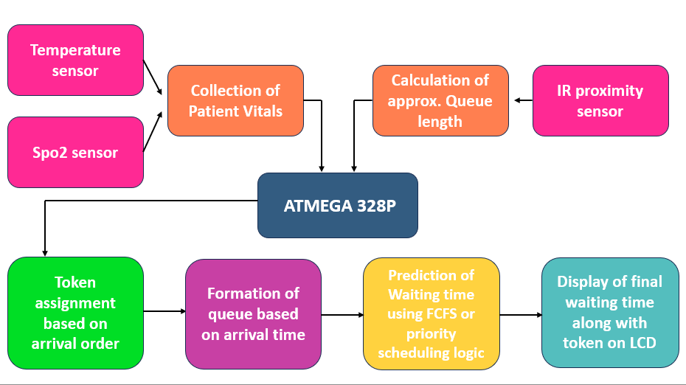
Fig. 2. Block diagram and operational workflow of the proposed Hospital Patient Flow Optimizer.

2.2.1 System Overview
Fig. 2 illustrates the working of the Hospital patient flow optimizer from their entry till doctor consultation. The proposed Hospital Patient Flow Optimizer prototype consists of three main functional units: the Patient Entry and Registration Unit, Vital Parameter Measurement Unit, and Queue Management and Consultation Allocation Unit. These units are processed sequentially, as illustrated in the block diagram, enabling patients to move smoothly from the registration area to the consultation area. Throughout the process, the system continuously maintains and updates the queue status and estimated waiting time. A detailed explanation of role of each block in Fig. 2 is as follows.
2.2.2 Patient Entry and Registration Unit
The Patient Entry and Registration Unit handles the patient’s registration and generates a unique token number for each individual. The participant enters the patient's name into the patient entry interface, and the system generates a token based on the patient's arrival sequence. Each patient receives a different token number, which is displayed and stored in the system database. This process creates the queue structure.
Patients are assigned tokens in the order of their arrival, following the First-Come, First-Served (FCFS) scheduling principle. The generated token number is used here to manage the patient's position in the queue and to track the patient throughout the remaining stages of the consultation system.
2.2.3 Vital Parameter Measurement
After registration, the patient proceeds to the Vital Parameter Measurement. During this stage, basic vital health parameters such as body temperature and oxygen saturation (SpO₂) are measured using corresponding sensors medical aids [11]. The measurement process is designed to take approximately the same amount of time for each patient, resulting in an average fixed service time during this stage.
The collected data are transmitted to the system for further processing and are used for the following purposes:
- Basic patient health monitoring.
- Detection of abnormal health conditions.
- Identification of patients requiring priority medical attention.
If any abnormalities are present, the system generates an alert and classifies the patient as a high-priority case. This information is then passed to the queue management system for priority adjustment.
2.2.4 Queue Management and Priority Assignment
After the vital parameters are checked, the system creates a consultation queue based primarily on the patient's arrival order and token number. The queue is initially structured using the First-Come, First-Served (FCFS) scheduling method. However, the system dynamically adjusted when critical patients are identified through their measured vital parameters.
The queue management system performs the following operations:
- Arranging patients according to their token number and arrival sequence.
- Calculating the approximate queue length based on the number of patients waiting in the system.
- Dynamically modifying patient priority when critical conditions are detected.
- Maintaining FCFS processing for normal patients.
Although FCFS forms the basic structure of the queue, patients with critical conditions are given higher priority and are moved ahead of non-critical patients. This ensures timely attention for emergency cases while maintaining an organized queue structure for regular patients.
2.2.5 Consultation Allocation
Based on the updated queue status and priority assignment, patients are called for consultation. The system ensures that normal patients are processed according to the FCFS principle, while critical patients receive priority consultation. The consultation time may vary for each patient depending on the patient's medical condition and the requirement of treatment.
This variation in consultation time is considered in the waiting time prediction model. By continuously monitoring the queue status, patient priority, and consultation progress, the system estimates the waiting time for each patient in real time. Hence people are made aware of their waiting time and the patient management becomes organized.
Overall, the proposed system integrates patient registration, vital parameter monitoring, queue management, priority adjustment, and real-time waiting time prediction. These features optimize patient flow, reduce unnecessary waiting time, improve resource utilization, and enhance the efficiency of hospital operations.

- RESULTS AND DISCUSSION
The proposed Smart Hospital Workflow and Patient Flow Optimizer was successfully developed to demonstrate how an automated system can improve patient movement, registration, preliminary health assessment, queue management, and consultation allocation in hospitals. The complete prototype consists of three main functional units: the Patient Entry and Registration Unit, the Vital Parameter Measurement Unit, and the Queue Management and Consultation Allocation Unit. These units operate sequentially to ensure that patients move through the hospital in an organized manner.

At the beginning of the workflow, the patient enters their details into the Patient Entry and Registration Unit. Once the registration process is completed, the system automatically generates a unique token number. This automatic token generation reduces manual errors and avoids confusion that may occur when patients are managed using conventional manual registration methods. Each patient is assigned an individual position in the queue, allowing the system to maintain an organized patient flow from the entry area to the consultation area. After registration, the patient proceeds to the Vital Parameter Measurement Unit, where basic health parameters are measured using sensors integrated with the embedded system. Parameters such as body temperature and oxygen saturation (SpO₂) are monitored and transmitted to the main controller for processing. The measured values are displayed on the LCD display, allowing patients and hospital staff to view the health information immediately. Since the measurement process is performed before consultation, the system can identify patients who may require urgent medical attention at an early stage. One of the important outcomes of the proposed system is its ability to provide priority-based patient handling. The system continuously evaluates the measured vital parameters and categorizes patients based on the predefined priority conditions. If a patient's health parameters indicate a potentially critical condition, the patient is given higher priority and moved forward in the consultation queue. This helps to reduce the waiting time for patients requiring urgent medical attention. At the same time, non-critical patients are managed using the First Come First Serve (FCFS) principle to maintain fairness in the overall queue. The combination of FCFS and priority-based scheduling provides a balanced approach to patient management. Under normal conditions, patients are served according to their token order. However, when the system detects a patient with abnormal or critical vital parameters, the queue is dynamically updated so that the critical patient can receive consultation earlier. This demonstrates that the proposed workflow does not depend only on the order of arrival but also considers the patient's health condition. Although non-critical patients may experience a slightly longer waiting period when an emergency case is prioritized, this approach is justified because rapid treatment of critical patients is essential in healthcare environments.
The proposed system also provides a real-time estimation of patient waiting time. The waiting time is calculated based on the current queue condition and the number of patients ahead of a particular patient. The estimated waiting time is displayed on the LCD along with other relevant information. This allows patients to understand their approximate waiting period and reduces uncertainty during the consultation process. The system also continuously updates the queue as patients complete the measurement and consultation stages. Fig. 3 shows the real-time display of the patient's vital parameters on the LCD, including the measured temperature and SpO₂ values. This confirms the successful integration of the sensor module with the embedded controller and display system. The system is able to collect, process, and display patient health data during the workflow. Fig. 4 shows the estimated waiting time and queue-related information displayed on the LCD, demonstrating the real-time operation of the patient flow optimization process. These results indicate that the proposed prototype can provide both patient health monitoring and queue management within a single workflow. Another significant result is the improvement in the utilization of medical staff and consultation resources. By maintaining an organized and continuously updated queue, the system helps reduce unnecessary idle time for doctors. Patients are allocated to the consultation process in a systematic manner, which can contribute to a more balanced workload. The dynamic nature of the queue also helps hospital staff respond to changes in patient priority without manually reorganizing the entire queue. The proposed system is designed using a low-cost embedded hardware platform and sensor-based components, making it suitable for small hospitals, clinics, and rural healthcare centers. Unlike many existing approaches that depend on large historical datasets, complex artificial intelligence algorithms, or high-performance computing systems, the proposed workflow performs patient monitoring and queue management using real-time data collected directly from the patient. The lightweight nature of the system reduces computational requirements while maintaining the essential functions needed for patient flow optimization.

Reference | Existing Work | Limitations | Proposed Patient flow optimizing System Advantage
Zhang et al. [1] | Used machine learning to predict patient waiting time from historical hospital data | Requires large datasets, not real-time, no direct queue control | Provides real-time waiting time estimation using live sensor and queue data without dependency on historical data
Ahmed et al. [2] | Applied queueing theory (FCFS, priority) to analyze hospital patient flow | Mainly theoretical/simulation-based, not implemented in real systems | Implements queue scheduling practically in a real-time embedded system
Patel et al. [3] | Used discrete event simulation to optimize hospital workflow and identify bottlenecks | High computational complexity, offline approach | Offers a simple, low-cost real-time solution using embedded hardware
Lee et al. [4] | Proposed AI-based scheduling using ANN-PSO optimization | Complex, expensive, high processing requirement | Uses lightweight hybrid scheduling suitable for embedded systems
Kumar et al. [5] | Developed a basic token-based patient queue management system | No prioritization for critical patients | Adds priority-based queue adjustment using real-time vital parameters
Khare et al. [6] | Designed AI-driven patient flow optimization using multiple algorithms | Software-heavy, limited hardware integration | Integrates sensors with real-time scheduling in a hardware-based system
Table 1. Comparison of existing patient flow management approaches with the proposed system highlighting key improvements and contributions
Table 1 compares the proposed system with existing patient flow management approaches. Existing methods have mainly focused on waiting-time prediction, queueing theory, discrete-event simulation, AI-based scheduling, and basic token management. Although these approaches provide useful solutions, several of them depend on large historical datasets, offline simulations, complex computational models, or software-based implementations with limited hardware integration. The proposed system addresses these limitations by combining automatic registration, real-time vital parameter monitoring, dynamic queue management, waiting-time estimation, and consultation priority adjustment in a single embedded workflow. The integration of the vital parameter sensors with the queue management system is one of the main contributions of this work. Instead of only predicting how long a patient may wait, the system actively manages the patient flow based on both queue position and health condition. Overall, the experimental results demonstrate that the proposed Smart Hospital Workflow and Patient Flow Optimizer can successfully organize patients from entry to consultation while identifying and prioritizing potentially critical cases. The system provides a practical combination of patient registration, health monitoring, dynamic scheduling, waiting-time estimation, and real-time display. The results show that a low-cost embedded system can be used to improve patient flow without requiring complex infrastructure. This makes the proposed system a suitable prototype for further development and implementation in smart hospitals, primary healthcare centers, and resource-constrained medical environments.
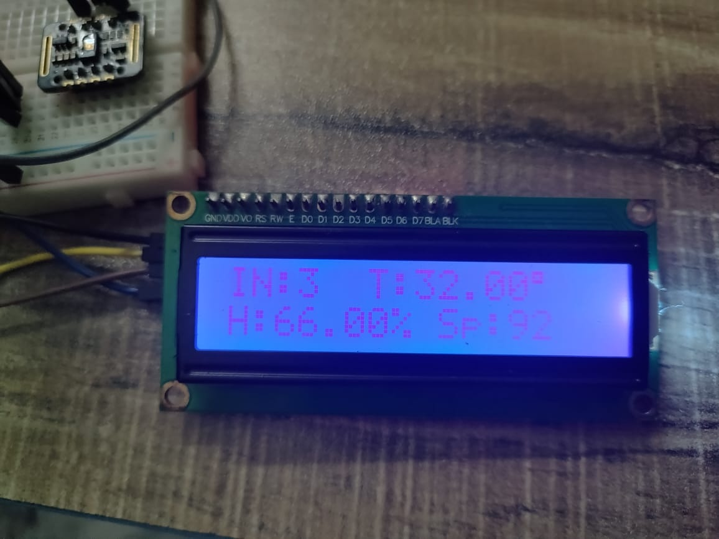
As can be seen, most existing methods are either prediction or simulation or computational optimization and have a small amount of real-time implementation and hardware integration. Proposed system, however, provides a viable solution which involves real-time monitoring of vital signs and dynamic queuing in low cost embedded framework. Not only does it forecast the waiting time for patients, but also it proactively manages the number of patients in the system. Fig. 3 and Fig. 4 shows the vitals and the waiting time being displayed in the lcd in real time working of the system.

Fig. 3. Real-time display of measured patient vital parameters.

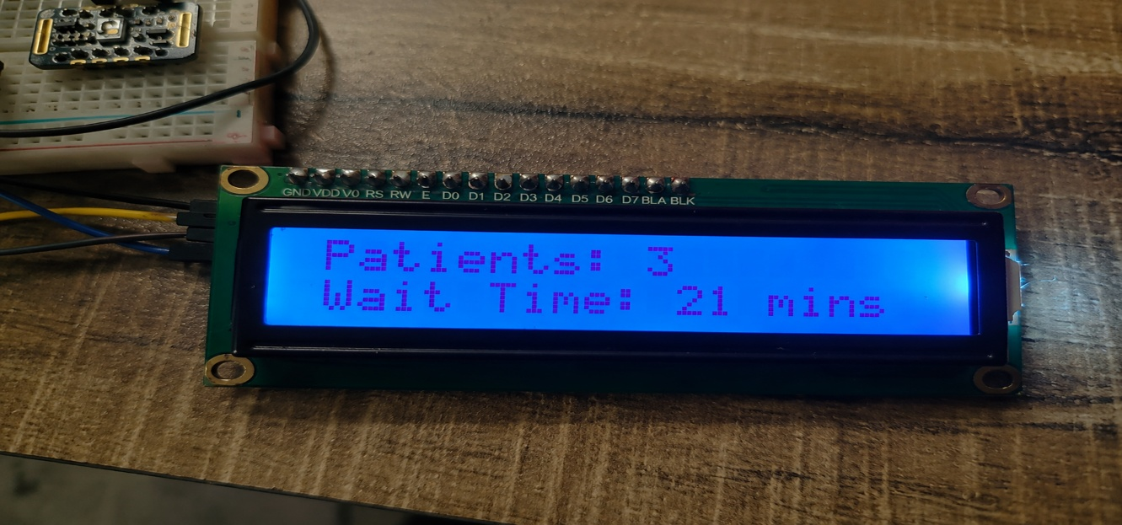

Fig. 4. Real-time display of patient inflow and estimated waiting time.


The fig 3 and 4 demonstrates the real-time working of the proposed Smart Hospital Patient Flow Optimizer using a 16×2 LCD display. The upper image shows the measured patient vital parameters, including the temperature and SpO₂ values, obtained through the sensor-based measurement system. These parameters are used to monitor the patient's basic health condition and identify cases requiring priority attention. The lower image displays the assigned patient priority and estimated waiting time, demonstrating the operation of the dynamic queue management system. In this case, the patient is assigned a priority value based on the measured health condition, and the waiting time is estimated as 21 minutes. The displayed results confirm the successful integration of patient vital monitoring, real-time processing, and intelligent queue scheduling. Overall, the system provides immediate and

Fig.5 Algorithmic Flow of Wait-Time Prediction using Round Robin and FCFS Scheduling

the algorithmic and mathematical framework developed for predicting patient waiting time in the Smart Hospital Patient Flow Optimizer. The model applies a two-stage scheduling concept: a First Come First Serve (FCFS) with constant service time for the vitals queue, followed by a standard FCFS for the doctor consultation queue.
In the vitals phase, each patient is allotted a fixed time slot for basic health checks such as temperature, heart rate, and SpO₂ measurement. This ensures equal processing time for all patients, functioning similarly to a simplified Round Robin scheme without cyclic iteration. In the consultation phase, the FCFS policy determines the order of treatment, where each patient’s waiting time depends on the cumulative consultation duration of the preceding patients.
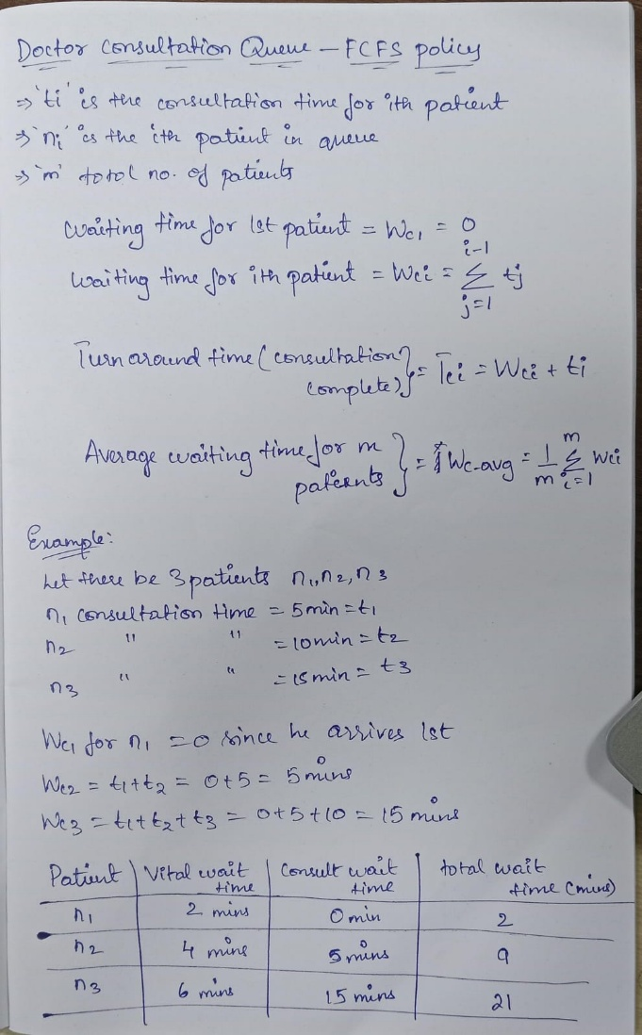

Fig.6 Mathematical Formulation and Queue-Based Calculation Model for Wait-Time Estimation
The formulations shown in Fig 6 mathematically represent these scheduling relationships, enabling computation of the total waiting time as the sum of the constant-time vitals delay and the variable consultation delay. This mathematical model directly guided the Arduino-based implementation, where real-time input from the IR sensor dynamically updates the estimated waiting period displayed on the LCD. The proposed logic effectively bridges theoretical scheduling with practical embedded operation, providing a reliable and low-cost method for automated waiting-time prediction in hospital environments.

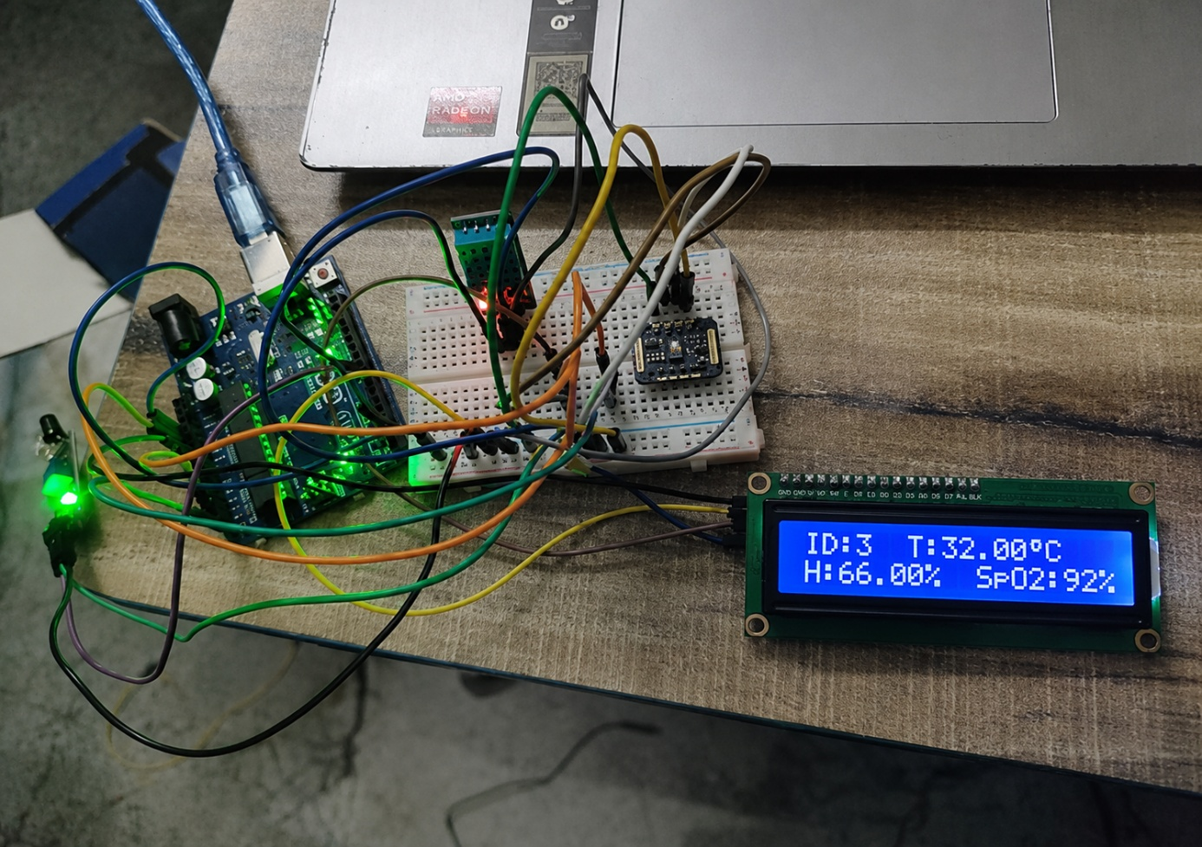
Fig.7 Working Prototype of the Smart Hospital Patient Flow Optimizer
The image represents the complete hardware prototype of the proposed Smart Hospital Patient Flow Optimizer is shown in fig 7. The system consists of a microcontroller, breadboard, sensor modules, connecting wires, and an LCD display integrated into a single setup. The sensors collect patient health parameters, which are processed by the controller in real time. The LCD clearly indicates the patient ID along with temperature, humidity, and SpO₂ values in accurate manner . The glowing indicator LEDs also provide a visual indication of the system's operating status. Overall, the setup demonstrates the successful integration of the sensing, processing, and display components for real-time patient monitoring.
- Conclusion
the proposed Smart Hospital Workflow and Patient Flow Optimizer provides an effective approach for improving patient management in healthcare facilities. The system integrates the Patient Entry and Registration Unit, Vital Parameter Measurement Unit, and Queue Management and Consultation Allocation Unit to create an organized and systematic patient flow from hospital entry to consultation. By combining automated token generation, real-time vital parameter monitoring, waiting-time estimation, and intelligent queue scheduling, the proposed system addresses important challenges found in conventional hospital environments, including long waiting times, overcrowding, and inadequate patient prioritization. The integration of temperature and oxygen saturation (SpO₂) monitoring enables the system to identify patients who may require immediate medical attention. The use of a hybrid First Come First Serve (FCFS) and priority-based scheduling approach ensures that normal patients are managed fairly while patients with critical conditions can be prioritized for consultation. This dynamic adjustment of the patient queue improves the responsiveness of the hospital workflow and can help reduce delays in providing attention to urgent cases. The system also demonstrates that an effective patient flow management solution can be implemented using a low-cost embedded platform, sensors, and real-time processing components without requiring expensive infrastructure or complex computational resources. This makes the proposed system particularly suitable for small hospitals, clinics, primary healthcare centres, and rural healthcare facilities where resources and technical infrastructure may be limited. Overall, the proposed work demonstrates that a simple and well-designed smart healthcare workflow can contribute significantly to improving hospital operations. The combination of automated registration, sensor-based vital monitoring, real-time queue management, waiting-time display, and consultation prioritization provides a practical foundation for modern healthcare management. The prototype can be further enhanced by integrating additional health parameters, cloud-based data storage, electronic health records, doctor availability information, mobile applications, and advanced prediction algorithms. With these future improvements, the proposed system has the potential to become a more comprehensive and reliable solution for smart hospital and healthcare management.
References
- S. Zhang, J. Smith, and L. Wang, “Predicting patient wait times in pediatric emergency departments using machine learning,” IEEE Journal of Biomedical and Health Informatics, vol. 24, no. 6, pp. 1750–1758, Jun. 2023.
- M. Ahmed and R. Gupta, “Application of queueing theory to patient flow in emergency departments,” IEEE Access, vol. 7, pp. 12345–12356, 2024.
- K. Patel, D. Sharma, and P. Verma, “Discrete event simulation for healthcare system optimization,” in Proc. IEEE Int. Conf. on Industrial Engineering and Engineering Management (IEEM), 2022, pp. 567–572.
- H. Lee and S. Kim, “Hybrid ANN-PSO approach for healthcare queue management,” IEEE Transactions on Computational Intelligence and AI in Games, vol. 12, no. 3, pp. 210–220, Sept. 2024.
- A. Khare, K. K. R. Penubaka, T. Chithrakumar, M. Geetha, D. Kamalavalli, and A. B. Jadhav, “AI-driven patient flow management in hospitals: Reducing wait times and enhancing care,” IEEE Access, vol. 11, pp. 45678–45689, 2023.
- R. Kumar and A. Singh, “Design of an automated patient queue management system in healthcare,” in Proc. IEEE Int. Conf. on Smart Computing (SMARTCOMP), 2023, pp. 98–103.
- A. Marengo, V. Santamato, and M. Iacoviello, “Smarter hospitals: Machine learning to optimize healthcare,” Sensors, vol. 23, no. 3, p. 1300, 2025.
- Marengo, A.; Santamato, V.; Iacoviello, M. Machine Learning in Biomedical Informatics: Optimizing Resource Allocation and Energy Efficiency in Public Hospitals. IEEE Access 2025, 13, 142331–142357.
- G. S and S. V. Kumar, "Adaptive Digital Twin Driven Queue Management with Bio Inspired Optimization for Smart Hospitals," 2025 International Conference on Sustainable Communication Networks and Application (ICSCN), Theni, India, 2025, pp. 232-238,
- Alotaibi, F.M., Ahmad, S., Akram, T. et al. A cost-optimized medical digital twin framework for secure and efficient patient data management in smart healthcare. Sci Rep (2026).
- Arulkumar, V., Aruna, M., Prakash, D. et al. A novel cloud-assisted framework for consumer internet of things based on lanner swarm optimization algorithm in smart healthcare systems. Multimed Tools Appl 83, 68155–68179 (2024).
- Manchanda, R., Panchal, S., Sandiri, R. et al. Energy-efficient clustering and routing for IoT-enabled healthcare using adaptive fuzzy logic and hybrid optimization. Sci Rep 15, 34619(2025)

